**Lab Exercise 1– Install Terraform on MacOS**

Installing Terraform on macOS can be done easily using **Homebrew** (recommended) or manually by downloading the binary.

### Install Terraform using Homebrew

1. Check if Homebrew is installed.

Run the following command in your terminal.

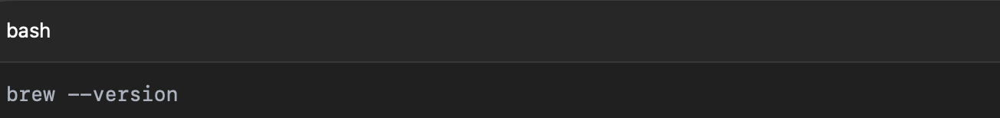

If you do not have Homebrew, install it by running.



1. Tap the HashiCorp repository



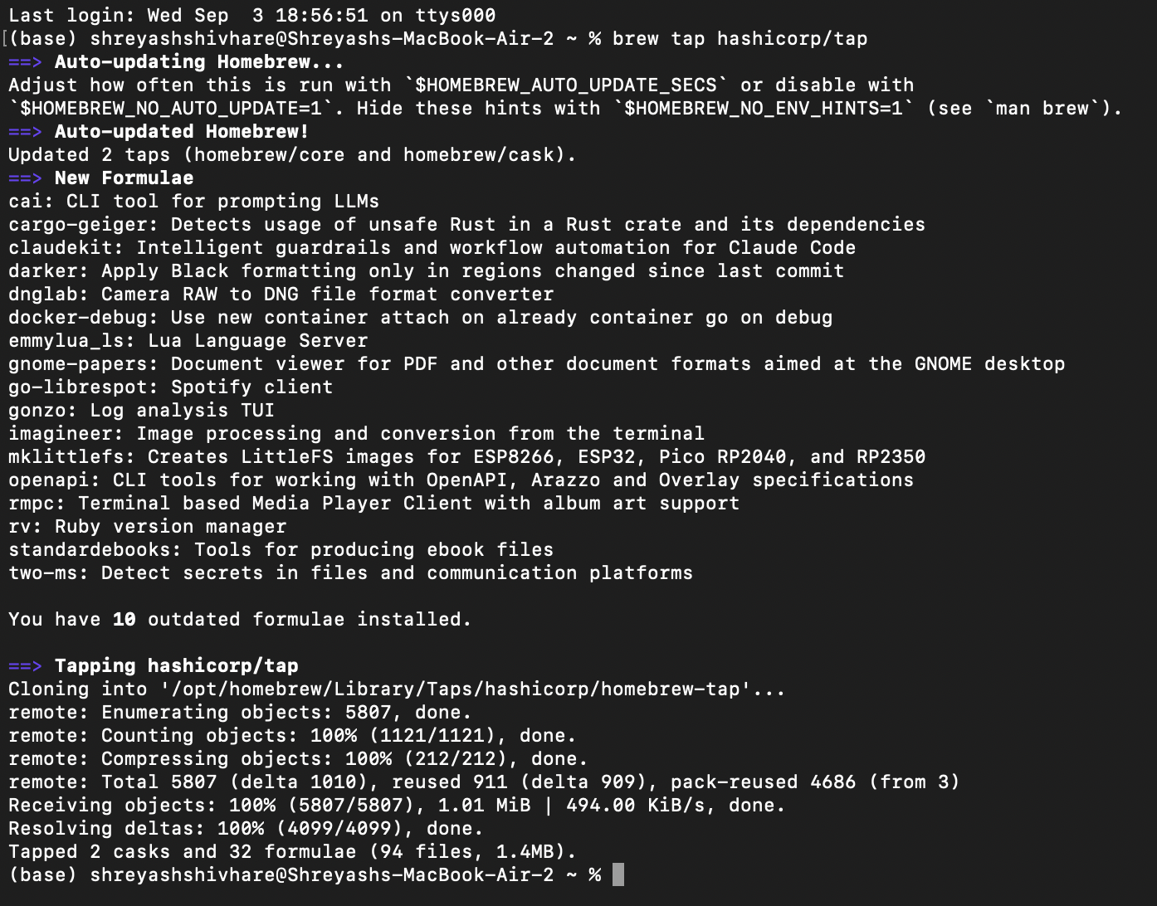



1. Install Terraform

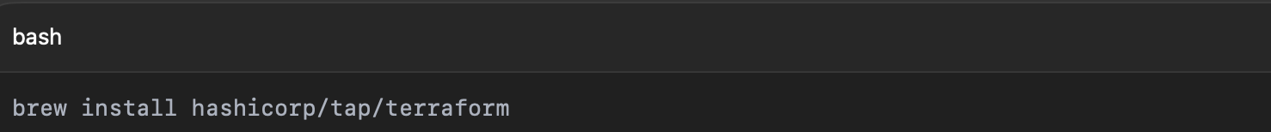

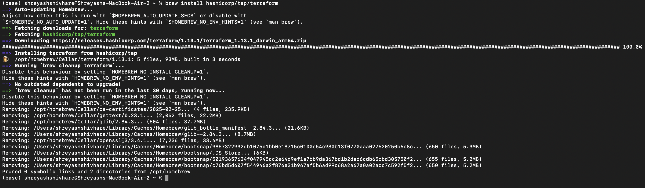

1. Verify the Installation

